1. Git Init command
2. Git configuring the mail and username for the repository
3. Git cloning the repository into local

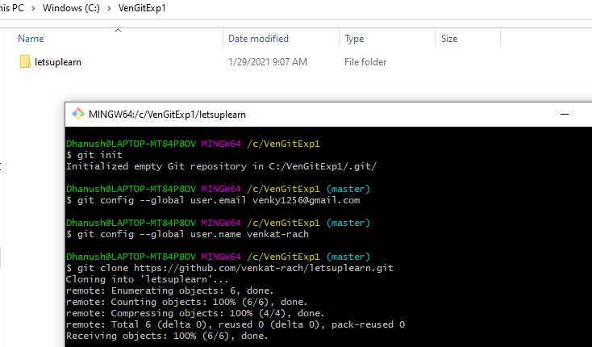

1. Can see the repository copied into local

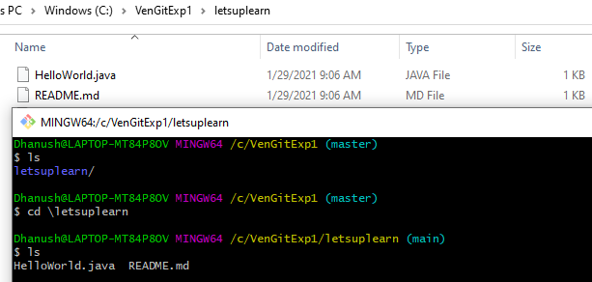

1. Created new file text123 in local and checked the status which is not commited

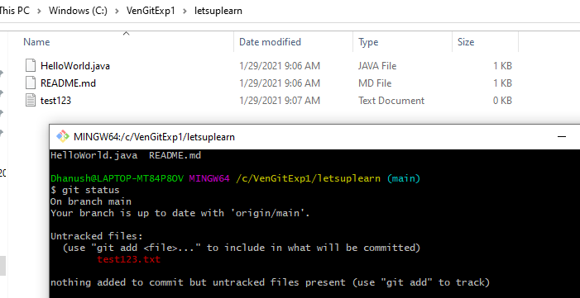

1. Committed the newly created file and committed to Github

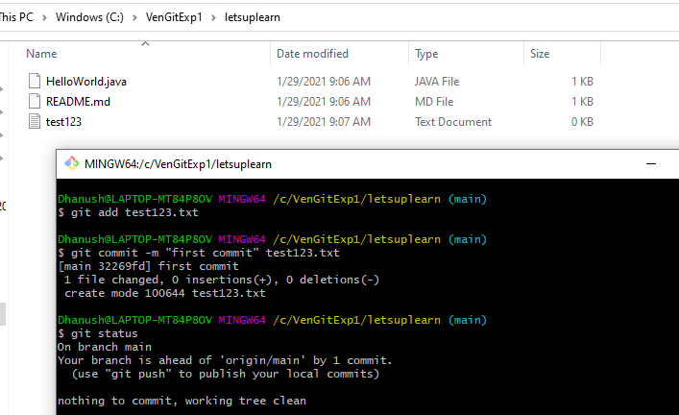

1. Pushing the file into Github

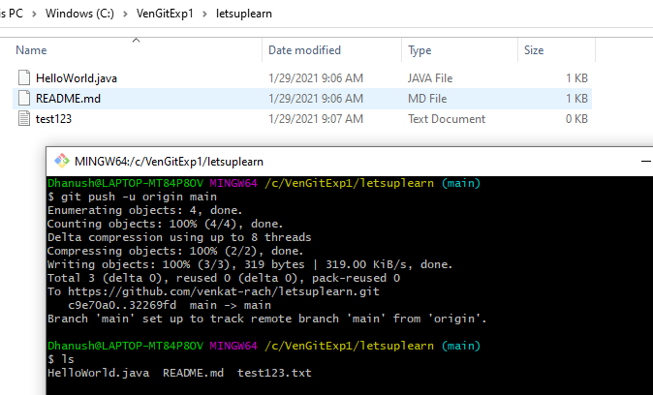

1. After push able to see the files in Github

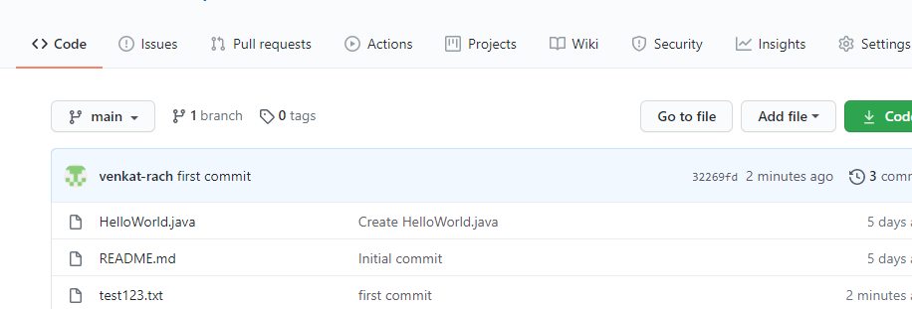

**Git branching**

1. Creating the branching and listing out the branches created

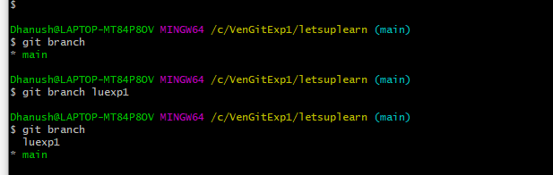

1. Moving to the newly created branch

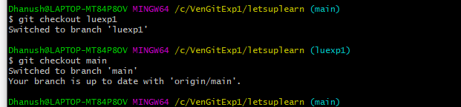

1. Deleting the branch

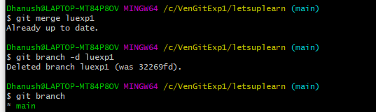

1. Force delete the branch

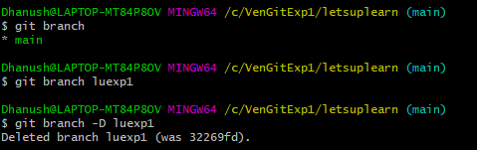

1. Force check out

